John Michael Go
Career Entry Level Java Programming
Date: Jan. 18, 2013

DAY 6

Program Name: Fibonacci

Objective: Program determines the Fibonacci sequence of the two numbers.

Algorithm:

1. User inputs first Fibonacci number.
2. User inputs second Fibonacci number.
3. User inputs the position of the desired number in the Fibonacci sequence.
4. Program determines the Fibonacci sequence of the two numbers.

Flowchart:
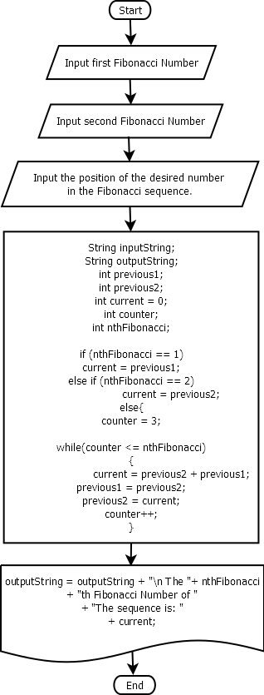

Pseudocode:

import javax.swing.JOptionPane;
public class Fibonacci {

public static void main(String[] args) {

//declare variables
String inputString;
String outputString;
int previous1;
int previous2;
int current = 0;
int counter;
int nthFibonacci;

inputString = JOptionPane.showInputDialog("Enter the first"
+ " Fibonacci Number: ");
previous1 = Integer.parseInt(inputString);

inputString = JOptionPane.showInputDialog("Enter the second"
+ " Fibonacci Number: ");
previous2 = Integer.parseInt(inputString);

outputString = "The first two numbers of the "
+ "Fibonacci Sequence are: "
+ previous1 + " and " + previous2;

inputString = JOptionPane.showInputDialog("Enter the position"
+ " of the desired number in "
+ "the Fibonacci Sequence: " );
nthFibonacci = Integer.parseInt(inputString);

if (nthFibonacci == 1)
current = previous1;
else if (nthFibonacci == 2)
current = previous2;
else{
counter = 3;

while(counter <= nthFibonacci)
{
current = previous2 + previous1;
previous1 = previous2;
previous2 = current;
counter++;
}
}
outputString = outputString + "\n The "
+ nthFibonacci
+ "th Fibonacci Number of "
+ "The sequence is: "
+ current;

JOptionPane.showMessageDialog(null, outputString);

}

}

Screenshot:
